Project Design Phase-II
Solution Requirements (Functional & Non-functional)

Date | 04 July 2026
Team ID | SWTID-2026-4563
Project Name | Visualizing Housing Market Trends: An Analysis of  Sales Price and Features Using Tableau
Maximum Marks | 2 Marks

Functional Requirements:
Following are the functional requirements of the proposed solution.
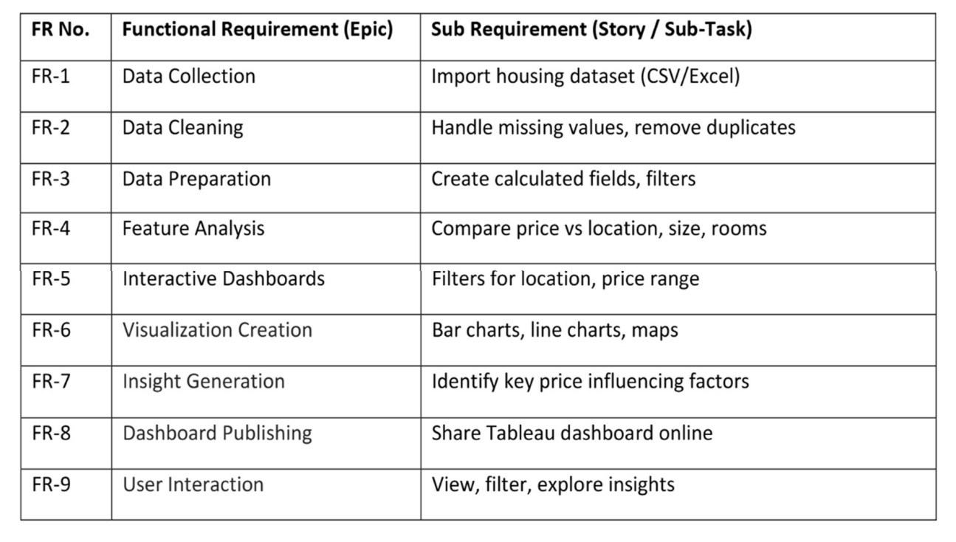

Non-functional Requirements:
Following are the non-functional requirements of the proposed solution.
